Documentation on difference between Transit Gateway and
VPC Peering

Transit Gateway / VPC Peering

There are two different approaches to connect multiple VPCs. One option is to use VPC Peering.There is a second option to enable communication between networks: AWS Transit Gateway.

Transit Gateway:

1. A Transit Gateway is a network transit hub that allows you to connect multiple VPCs, remote networks, and on-premises networks together.

2. It provides a central hub for traffic routing and simplifies the process of connecting multiple VPCs and networks.

3. With a Transit Gateway, you can create a single connection from a VPC to an on-premises network, and route all traffic from the VPCs to the on-premises network through the single connection.
4. You can also use the Transit Gateway to provide a connection between multiple VPCs, allowing them to communicate without having to configure peering or use VPNs or Direct Connect.

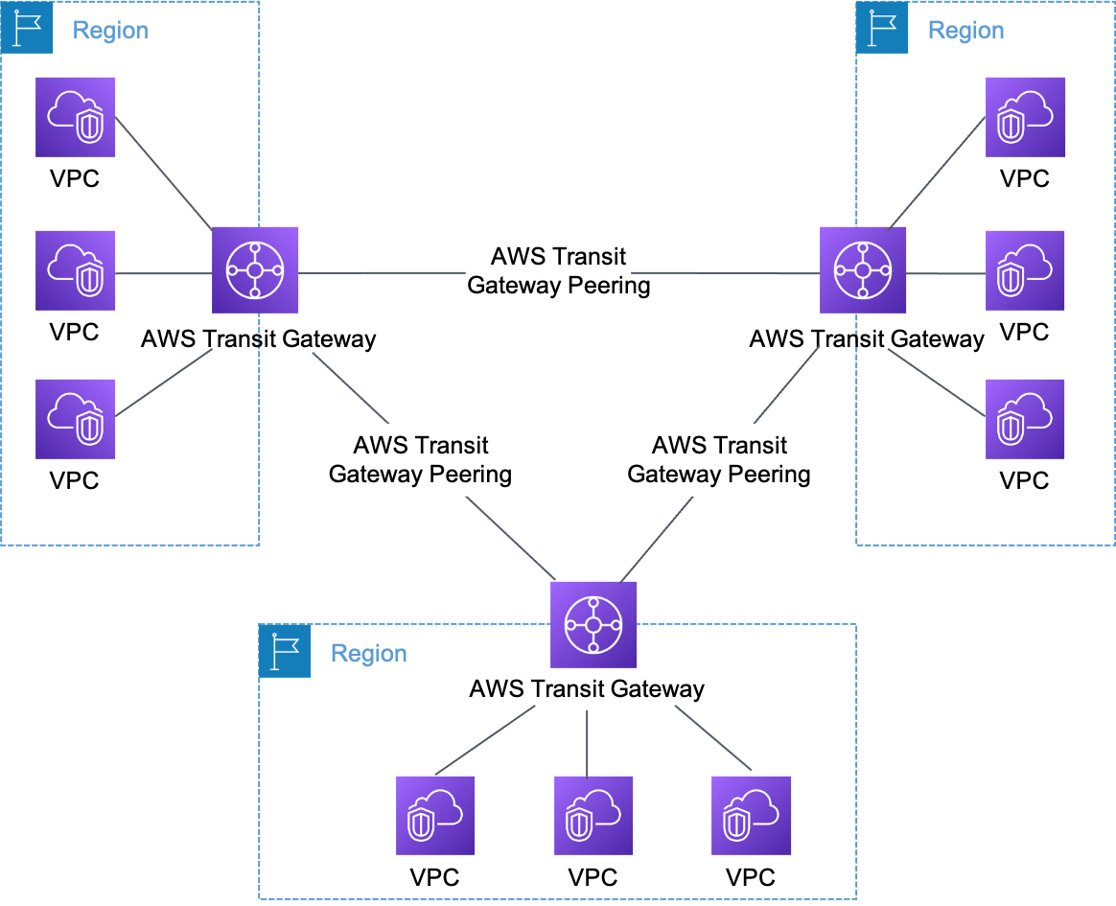

TRANSIT GATEWAY

To setup Transit gateway -

1. Create a Transit Gateway in the AWS Management Console.

2. Attach the necessary VPCs to the Transit Gateway.

3. Set up routing rules to control the flow of traffic between the attached VPCs.
4. Configure routes so that traffic can flow between the VPCs.

Advantages of AWS Transit Gateway

- Allows for more VPCs per region compared to VPC peering
- Better visibility (network manager, CloudWatch metrics, and flow logs) compared to VPC peering
- TGW Route Tables per attachment allow for fine-grained routing
- Complexity is based on region count

Disadvantages of AWS Transit Gateway

- Additional hop will introduce some latency
- Potential bottlenecks around regional peering links
- Priced on hourly cost per attachment, data processing, and data transfer

VPC Peering

1. VPC peering is a network connection between two virtual private clouds (VPCs) that enables traffic to be routed between them.

2. With VPC peering, you can connect two VPCs located in the same AWS Region, or in different AWS Regions.

3. VPC peering allows you to create a private connection between two VPCs, allowing resources within the two VPCs to communicate with each other.

4. This enables you to route traffic between them using private IPv4 addresses or IPv6 addresses.

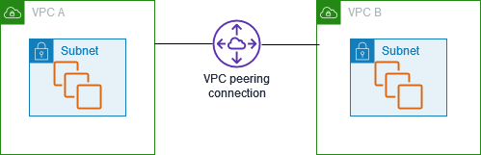

VPC PEERING

To setup VPC Peering:

1. Create two VPCs in the AWS Management Console.
2. Select the VPCs and initiate a VPC peering connection.
3. Accept the VPC peering connection request from the other VPC.
4. Set up routing rules to control the flow of traffic between the two VPCs.
5. Configure routes so that traffic can flow between the two VPCs.

Advantages of AWS VPC peering

- Priced only on data transfer
- No bandwidth limit

Disadvantages of AWS VPC peering

- Each VPC increases the complexity of the network
- Limited visibility (only VPC flow logs) compared to TGW
- Harder to maintain route tables compared to TGW

